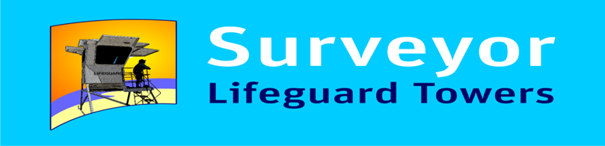

Attension: Lifeguard Managers and Surf Life Saving Clubs

Subject : 2017/2018 NSW Govt. “Shark Observation Grant”

The Depatment of Primary Industries of N.S.W. has announced that $200,000.00 will be made available through their “Shark Observation Grant.”

Placing Lifeguards and Lifesavers in elevated positions for early detection of “Shark Activity”and “Drowning Victims” is worlds best practise for beach patrolling.

SURVEYOR have been designing and building BEACH OBSEVATION TOWERS for over 30 years.

Now is your opportunity to apply for funding to purchase one of these unique towers which not only makes your staff more efficient but also protectes them from” WIND – RAIN – SUN” complying with WHS requirments.

Pricing Guide Surveyor “Junior” from $35,000.00 + G.S.T.

Surveyor “APEX” from $75,000.00 + G.S.T.

For information visit our web site www.lifeguardtowers.com.au or,

Contact Ken Holloway for a detailed quote and documents to support your grant aplication on 0422889813 m ken52@skymesh.com.au

